Flash Flood Warning System

1. Problem Statement
Malaysia’s national flood monitoring infrastructure, the National Flood Forecasting and Warning Project (PRABN) by the Department of Irrigation and Drainage (DID), provides reliable coverage at the river-basin scale, but smaller drainage lines and canals, where localized urban flash flooding often originates, remain largely unmonitored or reliant on inconsistent manual observation (Malaysia., 2019; Networks, 2025). As a result, by the time rising water is visually detected at those sites, the time available for warning and response is minimal, especially during fast-onset flash flood events.

1.1 Existing Solution
HDL Solutions Sdn Bhd addresses the early flood monitoring gaps partially; however, the solutions are built for river/basin scale telemetry density and enterprise-level deployment costs, leaving canal- and drain-level monitoring barely covered. They built the hardware behind DID’s PRABN project. The solution consists of Radar/bubbler/float-based water level sensors, plus rainfall and weather monitoring equipment. Their remote terminal unit, RTU ECO-I (S701), is deployed with dual communication pathways. They include primary cellular communication and satellite backup, partnering with AST Networks. They power their system using Solar panels and LiFePO4 batteries and include siren controllers for onsite warning (Bhd).

1.2 Proposed Solution
This project addresses the gap by designing a comparatively low-cost, PLC-based water level monitoring system at the drainage/canal level that combines real-time ultrasonic sensing, rate-of-rise detection, and rainfall data fusion to provide earlier and more localized flood warnings than threshold-only basin-scale systems currently offer.
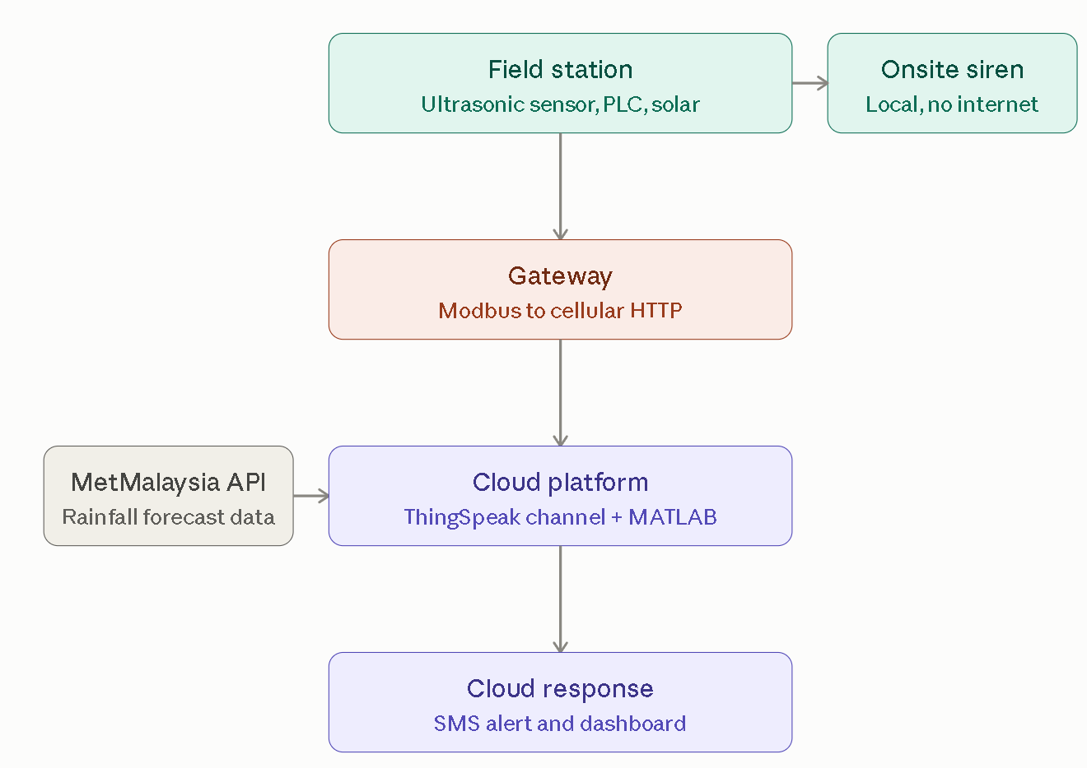

1.3 Comparison
PRABN with HDL Solutions | Proposed Solution
Only threshold-based water level Monitoring | Threshold-based + rate-of-rise water level monitoring + rainfall data
Deployed at the river basin scale, not suitable for early flash flood warning in urban areas | Deployed at the drainage/canal level in the more flood-affected urban areas, since one of the most important factors of flash floods in urban areas is drainage overflow, especially during the monsoon season (Buslima et al., 2018)
Includes satellite backup during extreme weather in case of cell network disruption for sending warnings | Since deployed in urban areas, sirens act as the secondary alerting system on top of SMS warnings
System and equipment used are costly, and reported to have poor accuracy during phase 1 (Yiau, 2024). | Equipment is reported to have higher accuracy and cost optimal.

2. Market Value

2.1 Target Customers who are affected by the problem
Flash floods are mainly characterized by their short yet rapid occurrence, the sudden chance of water discharge that is unpredictable and wreaks havoc on affected local areas. Without an alert system or warning notification, it can cause major harm to residents residing in flood-prone areas that can be reduced or avoided. Without sufficient time to respond to flash floods, residents may be more easily hurt and even lose their lives; in Malaysia, floods are reported to cause 90% of total injuries by natural disasters (Maqtan et al., 2022). Furthermore, floodwater can be contaminated by sewage, pollution, and chemicals, not only endangering those who are in the vicinity but also helping spread diseases such as cholera (Kl et al., 2024). Not only that, but those who cannot evacuate in time due to insufficient response time will have a harder time evacuating and will be abruptly displaced, especially without their important belonging. In addition to physical pain, those residents will also suffer psychological pain with signs of anxiety, stress, and more (Ali et al., 2017) (Kl et al., 2024). Therefore, an early flash flood warning system is crucial for minimising the negative impact of flash flooding in flood-prone areas, which the team has proposed.

2.2 Do the target customers exist
Based on the recorded flood events in Sarawak in 2025 (Recorded Flood Event in Sarawak Year 2025 (Feb - June) - Official Website of Department of Irrigation and Drainage Sarawak, 2025), there are a total of 189 floods reported, and approximately half of them are associated with heavy rainfall. A total of 8 cities are affected by flash floods. Sibu recorded the highest number of flash flood events, with 2 divisions totaling 25 counts, followed by Seri Aman with 19 counts, and Miri and Bintulu with 13 counts each. The most frequently affected area was at RH Silvester, Kampung Kara, which experienced 5 flooding events. In terms of severe flash floods, which are defined as flood events where the water level exceeded 1 meter, Bintulu recorded 3 events, while Sri Aman and Sibu each recorded 2 events.
These figures clearly show that flash floods are a common natural event happening in Sarawak. Together with the impact caused by flash floods discussed above, this indicates that there is a substantial market for an early warning system to decrease the impact.
Besides that, frequent flood events are located close to rivers in rural areas. For example, RH Silvester, Kampung Kara, and RH Magdeline Entayang, Kampung Melinau Baru, the top 2 recorded flooded areas are located close to Batang Mukah River. This distribution may indicate a limitation in the existing flood records, as recorded events are mainly concentrated in populated areas near river streams. Flash flood events in residential areas farther from rivers may be underreported, which means the total number of flash floods may be higher.

3. Solution value & Evidence Acceptance

3.1 Value to target customers
One of the targets is the Department of Drainage and Irrigation Sarawak will greatly benefit from the project solution because this solution closes the canal/drainage level monitoring gap at a lower cost per unit than the existing river basins system (Gul et al., 2026). This would greatly decrease the cost the government needs to spend on monitoring flash flood warnings in a particular system, as it is more focused and enables more places to be monitored with the same budget. The DID’s responders and engineers would also add value to the solution, as the system would give the rate-of-rise detection an earlier alert before it even hits the major thresholds, leading to much more lead time for them (Han et al., 2023). The live dashboard using Node-RED and ThingSpeak would also give real-time situational data readings instead of relying on threshold only reading thus making it easier to prioritise those that need immediate attention.

3.2 Evidence of Acceptance
The evidence can be shown by the existing paying market of DID’s contract with HDL Solutions (HDL Solutions, n.d.) shows that they already accept and provide funds to the flood monitoring system technology category. The DID has also been using an IoT-based flood detection system called the Integrated Flood Detection and Notification System. It uses sensors that are placed at rivers to monitor their water levels and send data automatically to them using a GSM network (Maidin et al., 2022). The DID also accepts early and predictive alerts, not just the threshold reading. They already built a system called NaFFWS (National Flood Forecasting and Warning System). This system uses real-time data to give warnings to authorities 48 hours prior to flooding and can help in forecasting floods (HR Wallingford, n.d.); thus, a new solution that would improve their system would be accepted.

3.3 Real World Research Examples
Other research has already been done and tested similar to the systems that are proposed, and results show that this type of solution actually works. (Wiangnak et al., 2026) built and tested a flood warning system in Thailand at a high-risk river site. Their system uses water sensors, cameras, and AI to detect rising water levels and can predict in rising of water level thus give early alert for a flash flooding situation. Their research shows that even after 60 days of operation, it stayed online for more than 97% of the time and can catch 90% of flood warnings. The second is a closer example in Kuching. (Zulkapli et al., 2025) built a similar IoT flood monitoring system for an urban area of Sarawak. They use water level and rain sensors that are connected to a microcontroller that alerts and sends it straight to a mobile application. Their system also automatically opens up valves that can help drain the excess water to prevent water accumulation.

4. Reference
Bhd, S. S. S. Projek Ramalan Amaran Banjir (PRAB). Retrieved 16 September from https://hdls.com.my/projects/projek-prab/#
Buslima, F., Omar, R. C., Jamaluddin, T. A., & Taha, H. (2018). Flood and flash flood geo-hazards in Malaysia. Int. J. Eng. Technol, 7(4), 760-764.
Gul, I., Abdelkader, M., Mackelburg, K., & Temimi, M. (2026). Dual-purpose and low-cost IoT-based sensor network for real-time rainfall and urban flood monitoring. IEEE Internet of Things Journal, 13(4), 6640–6654. https://doi.org/10.1109/JIOT.2025.3636404
Han, M., Rao, Y., Nie, W., Wang, D., Wu, F., & Shi, L. (2023). An early warning system for landslide risks in ion-adsorption rare earth mines: Based on real-time monitoring of water level changes in slopes. Minerals, 13(2), Article 265. https://doi.org/10.3390/min13020265
HDL Solutions. (n.d.). Home. https://hdls.com.my/
HR Wallingford. (n.d.). Building a flood forecasting and warning system for Malaysia. https://www.hrwallingford.com/projects/building-flood-forecasting-and-warning- system-malaysia
Kl, K. H. B. K. (2024). From risk to readiness: exploring community preparedness for monsoon floods in East Coast Malaysia. Disaster Advances. https://www.academia.edu/download/133685535/181da031037.pdf
Maidin, S. S., Lau, B.-Y. S., Othman, M., Latif, A. A., & Mat Saad, M. F. (2022). Data governance conceptual model for IoT (DGCMIoT) in flood management, using the Department of Irrigation and Drainage (DID) Malaysia's Integrated Flood Detection and Notification System as a case. Journal of Pharmaceutical Negative Results. https://www.pnrjournal.com/index.php/home/article/download/7680/10179/9327
Malaysia., D. o. I. a. D. (2019). NATIONAL FLOOD FORECASTING AND WARNING CENTRE (PRABN). Retrieved 16 September from https://publicinfobanjir.water.gov.my/mengenai-kami/prabn/?lang=en
Maqtan, R., Othman, F., Wan Jaafar, W. Z., Sherif, M., & El-Shafie, A. (2022). A scoping review of flash floods in Malaysia: current status and the way forward. Natural Hazards. https://doi.org/10.1007/s11069-022-05486-6
Networks, A. (2025). AST Networks & HDL Solutions Sdn Bhd (HDLS) secure Flood Sensor Monitoring deal with Malaysian Government. Retrieved 16 September from https://ast-networks.com/insights/news/flood-sensor-monitoring/
Recorded Flood Event in Sarawak Year 2025 (Feb - June) - Official Website of Department
of Irrigation and Drainage Sarawak. (2025). Sarawak.Gov.My. https://did.sarawak.gov.my/web/subpage/webpage_view/1832
Wiangnak, V., Wiboonrat, M., & Duangsuwan, S. (2026). Development of an AIoT-based early flash-flood warning system for smart rural disaster resilience. Sensors, 26(11), Article 3512. https://doi.org/10.3390/s26113512
Yiau, C. N. (2024). Phase 1 of Malaysia's RM1.06b flood forecasting, warning system only 5.6% accurate — PAC. The Edge Malaysia. https://theedgemalaysia.com/node/705280
Zulkapli, Z., Janin, Z., Masrie, M., Zolkapli, M., Burham, N., & Shahbudin, S. (2025). IoT- based flash flood monitoring with mobile notifications alerts for urban areas. In 2025 IEEE 8th International Conference on Electrical, Electronics, and System Engineering (ICEESE). IEEE. https://doi.org/10.1109/ICEESE66784.2025.11212762

5. Appendix
This is the flood event data being processed and analysed for the project.

